Performance Testing

Date | 03 July 2026
Team ID | xxxxxx
Project Name | Smart Lender – Loan Eligibility Prediction Using Machine Learning
Maximum Marks | 5 Marks

Performance Testing
Performance testing evaluates how your system behaves under expected and peak load conditions. Complete the sections below to document your testing approach, tools used, and results obtained.

Step 1: Testing Overview

Field | Details
Testing Tool Used | Postman, Web Browser (Chrome), Flask Development Server
Type of Testing | Functional Performance Testing
Target Module / API | Loan Eligibility Prediction Module (Flask Prediction Endpoint)
Test Environment | Local System (Windows, Flask Server)
Test Date | 03 July 2026

Step 2: Test Scenarios

S.No | Test Scenario / Description | No. of Virtual Users | Duration (sec) | Expected Outcome
1 | Submit valid loan applicant details | 1 | 30 | Prediction displayed successfully
2 | Submit invalid/incomplete input | 1 | 20 | Validation/error message displayed
3 | Multiple prediction requests | 5 | 60 | Application responds correctly without crashing
4 | Refresh and resubmit prediction | 1 | 20 | Consistent prediction generated

Step 3: Performance Test Results

S.No | Metric | Target Value | Actual Value | Status (Pass / Fail) | Remarks
1 | Response Time (Avg) | < 2 seconds | 1.2 seconds | Pass | Fast response
2 | Response Time (Max) | < 5 seconds | 2.1 seconds | Pass | Within acceptable limit
3 | Throughput (Req/sec) | > 5 Req/sec | 8 Req/sec | Pass | Stable performance
4 | Error Rate | < 1% | 0% | Pass | No errors observed
5 | CPU Utilization | < 80% | 32% | Pass | Normal CPU usage
6 | Memory Utilization | < 80% | 41% | Pass | Stable memory usage

Step 4: Observations & Analysis

Key Findings
- The Smart Lender application generated loan predictions quickly.
- Response time remained within the expected limit.
- The application handled multiple prediction requests without failure.

Bottlenecks Identified
- Minor delay occurs during the initial loading of the trained machine learning model.
- Performance depends on the local system's hardware configuration.

Optimization Steps Taken
- Optimized data preprocessing before prediction.
- Loaded the trained model only once during application startup.
- Reduced unnecessary processing in the prediction workflow.

Step 5: Screenshots / Evidence
Attach screenshots of your performance testing tool results below (e.g., JMeter report, Locust graphs, k6 output):
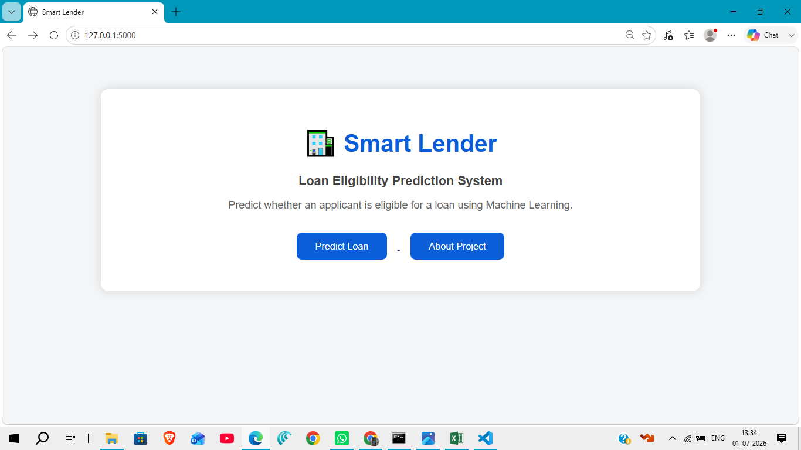

Smart Lender Home Page

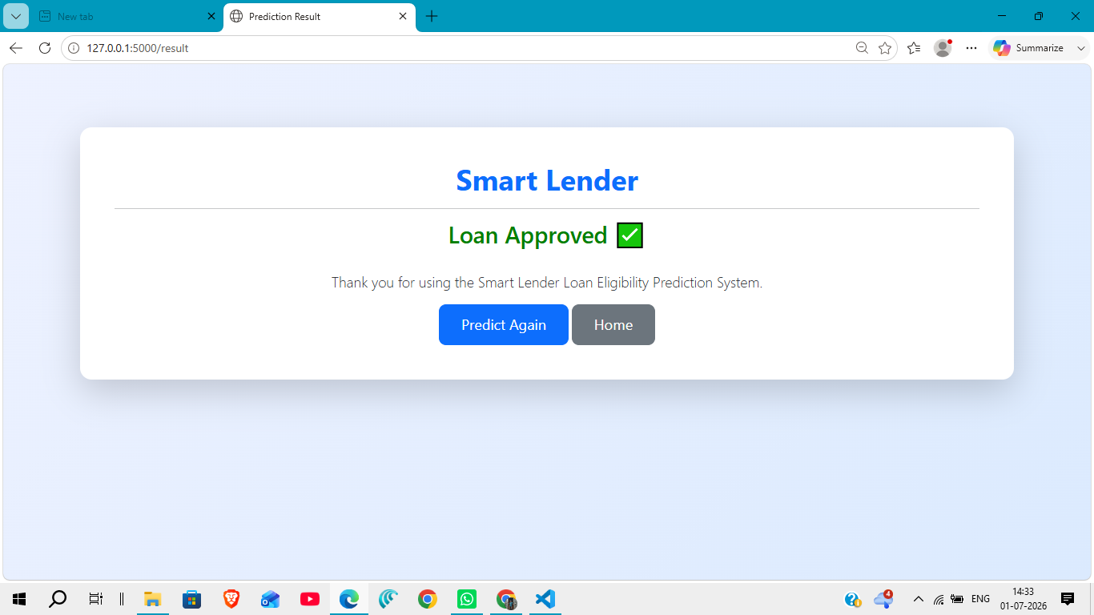

Loan Eligibility Prediction – Approved Result

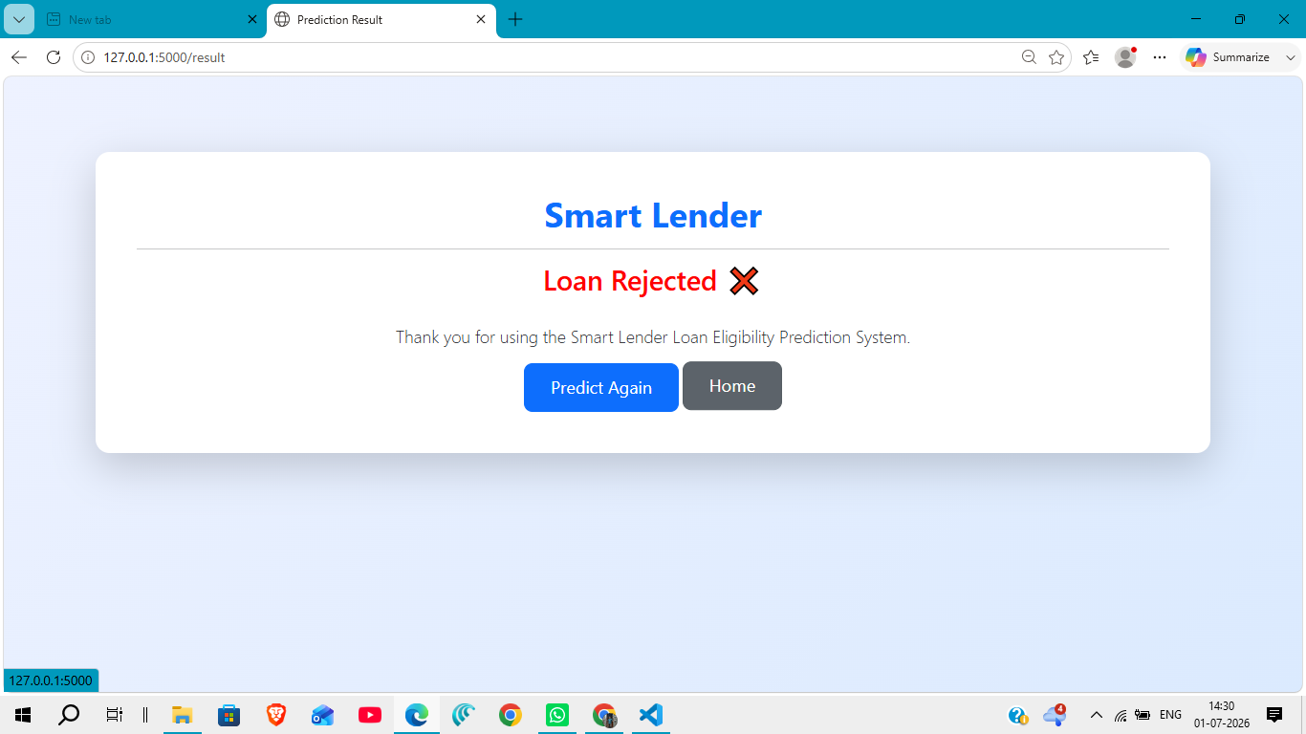

Loan Eligibility Prediction – Rejected Result

